2022 Pendleton Class Schedule
PENDLETON CENTER: 928-771-5794
*Classes are subject to change.*
MONDAYS  7am -12pm  1:00pm – 4:30pm | TUESDAYS  7am -12pm  1:00pm – 4pm | WEDNESDAYS  7am – 12pm  1:00pm – 4:30pm | THURSDAYS  7am – 12pm  1:00pm – 4pm | FRIDAYS  7am – 12pm  1:00pm–4:30pm
7:30 am  SilverSneaker Yoga | 7:45 am – 8:15 am  Equipment Orientation | 7:30 am  SilverSneaker Yoga |  | 7:30 am  SilverSneaker Yoga
9:00 am  SilverSneaker Classic | 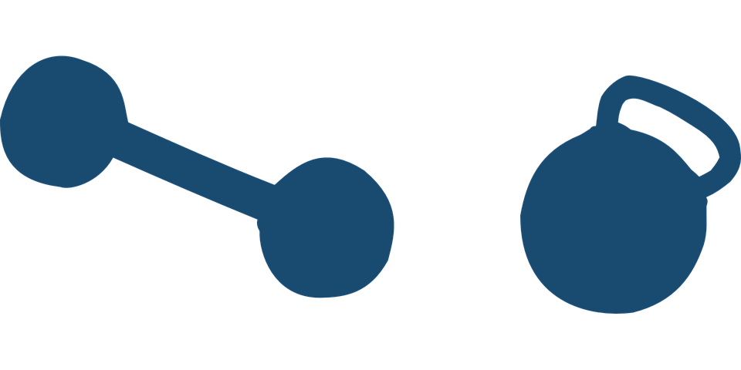 | 9:00 am  SilverSneaker Circuit | 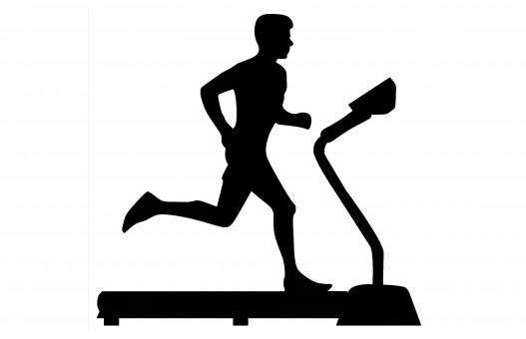 | 9:00 am  SilverSneaker  Circuit
10:00 am  Total Strength | 10:00 am  Ener-Chi | 10:00 am  Total Strength | 10:00 am  Ener-Chi/Stretch | 10:00 am  Total Strength
11:00 am  Silver & Fit Explore | 11:00 am  Balance & Strength | 11:00 am  Silver & Fit Explore | 11:00 am  Balance & Strength | 11:00 am  Silver & Fit Explore
2:30 pm  Cardio Blast | 2 pm or 3pm  Equipment  Orientation | 2:30 pm  Cardio  Blast | 2pm or 3pm  Equipment  Orientation
*Please contact the fitness center to sign up for classes*

Balance Evaluation: Are a group of tests that check for balance disorders. A balance disorder is a condition that makes you feel unsteady on your feet and dizzy

Total Strength: This class is for the more advanced person. Clients will be doing lunges, squats and total body exercises to help improve strength and balance. *This is an advanced class*

Balance & Strength: Perfect for all fitness levels. This class will help with strength, posture, and improve daily activities. Clients will use weights, resistance tube/band, and soft ball. These are not required. Sturdy chair is recommended.

Ener-Chi: combines modified tai chi forms and qigong exercises to promote wellness. Purposeful movement performed with awareness and focused breathing cultivates a strong, balanced body and a calm mind.

SilverSneaker Classic: Have fun and move to the music through a variety of exercises designed to increase muscular strength, range of movement and activities for daily living. Weights, balls, and resistance bands are used. This equipment is not required. A sturdy chair is recommended.

SilverSneaker Circuit: Combine fun with fitness to increase your cardiovascular and muscular endurance power with a standing circuit workout. Clients will use weights, resistance bands and balls. Equipment can be subsituted.

SilverSneaker Yoga: Will move your whole body through a complete series of seated and standing yoga poses. Chair support is offered to safely perform a variety of seated and standing postures designed to increase flexibility, balance and range of movement. Sturdy chair is recommended.

Explore Class: Designed for older adults who are just getting started or are returning to an exercise routine. This is a gentler, slower workout, with seated exercise options for the more de-conditioned individual, with extra care to explain the moves and how to safely integrate exercise as part of daily activity. Study chair is required. Client uses weights, balls, and resistance bands. These are not required and can be substituted.

Cardio Blast: A total body, aerobic and strength conditioning workout. Class combines full-body strength training with cardio bursts designed to tone and improve your endurance. Modifications for all fitness levels provided. The equipment that is commonly used is weights, resistance bands and balls. Substitutions can be used.

